**Ideation Phase**

**Define the Problem Statements**

|  |  |
| --- | --- |
| DATE | 19 September 2022 |
| TEAM ID | PNT2022TMID09994 |
| PROJECT TITLE | Hazardous Area Monitoring for Industrial Plant Powered by IoT |
| MAXIMUM MARK | 2 Marks |

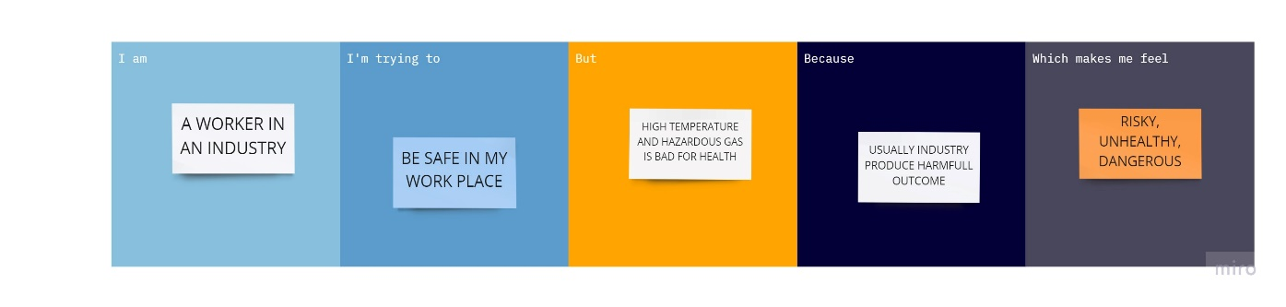

|  |  |
| --- | --- |
| **Problem Statement (PS):** | People who are working in industry are in chance of affecting by hazardous gases, high temperature, high humidity, fire explosion. Sometimes the conditions may become critical which may lead to loss of property and human loss. |
| **I am**  **(WORKER IN AN INDUSTRY)** | A worker in an industry, whom is in a risk of working in a hazardous and harmful sector in an industry. Whose life is in risk and health condition may became bad. |
| **I’m trying to** | Be safe in my work place and prevent my health from unwanted outcomes getting out from industry. |
| **But** | I can’t be in a risk while working and can’t be in a fear of being affected. |
| **Because** | Usually industry will emit hazardous gases, and emit high temperature during process, sometime fire explosion may happen. |
| **Which makes me feel** | Frustrated and Unsecured to work in an industry sector |